E-CONTENTS OF WORKSHOP

TECHNOLOGY – II

# CHAPTER– 1(CUTTING TOOL AND TOOL MATERIALS)

## CUTTING TOOLS AND ITS TYPES

The tool which are used for the purpose of cutting the materials in the desire shape and size are called cutting tool.

## SINGLE POINT CUTTING TOOL

The cutting tool terminating in a single point are termed as a single point cutting tools. These tool are used on lathes, shaper, planers etc.

## MULTI POINT CUTTING TOOl

The cutting tool being composed of more than one single point are termed as multi point cutting tool. e.g. milling, cutter, drills, broaches, grinding wheels etc.

## SINGLE POINT CUTTING TOOL GEOMETRY

* 1. **TOOL SIGNATURE**

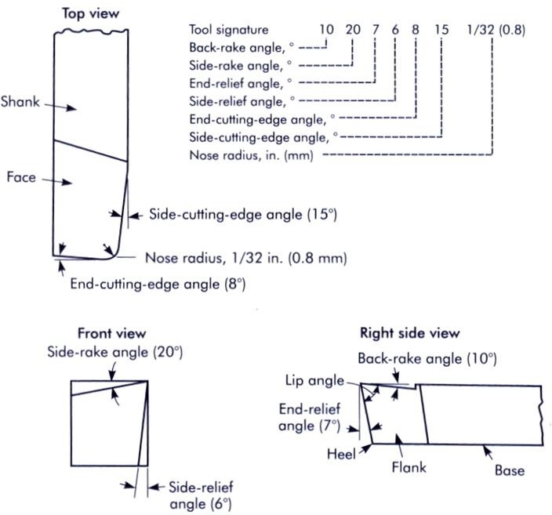

## CUTTING SPEED

Cutting speed of a cutting tool may be define as the speed at which the cutting edge passes over the material.

## DEPTH OF CUT

The perpendicular distance measured from the machined surface to the un-cut surface of the work piece.

# CHAPTER – 2 (DRILLING)

* 1. **PRINCIPLE OF DRILLING-**Drilling machine is used to produced hole in the work piece. The end cutting tool used for drilling holes in the work piece is called the drill.

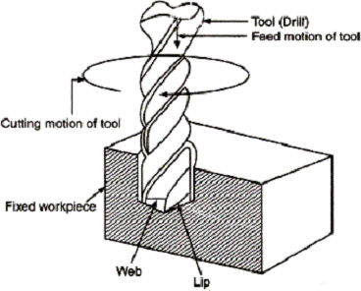

## CLASSIFICATION OF DRILLING MACHINE

* + 1. **Portable Drilling Machine.**

This is a small drilling machine which can be easily carry to work piece. It is a generally employed for drilling hole.

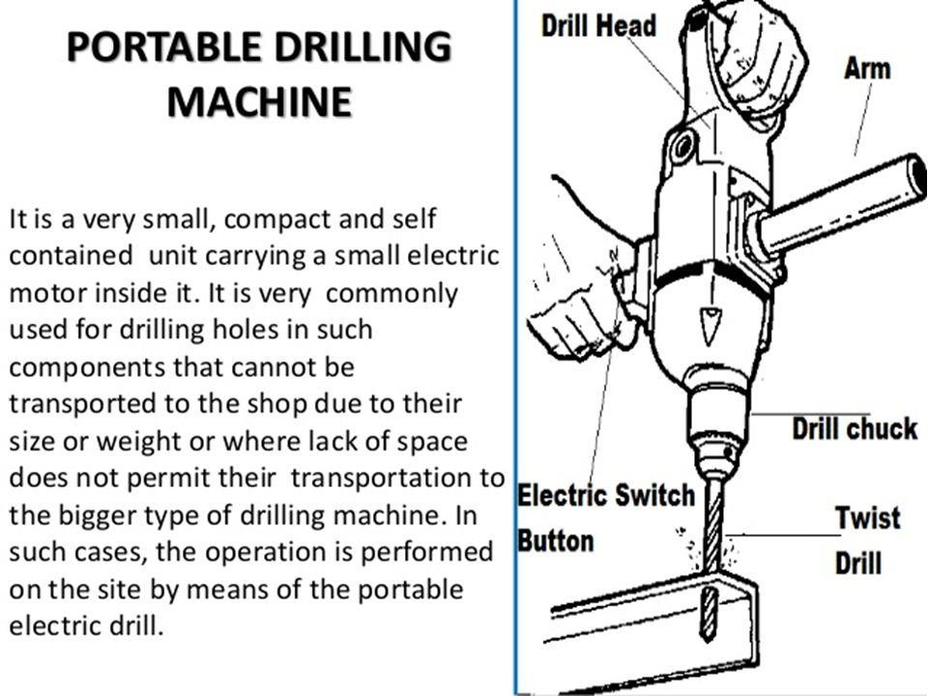

## SENSITIVE OR BENCH DRILLING MACHINE

It is light and simple drilling machine of a small height. It is usually fitted on a bench and hence, it is called bench drilling machine.

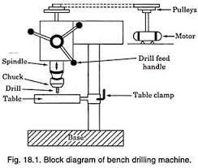

## UPRIGHT DRILLING MACHINE –

This machine drives its names from the facts that it has got considerable height and table seems to be standing quite above the base

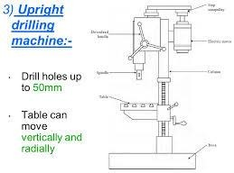

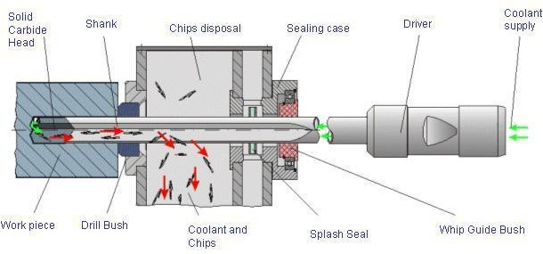

## DEEP HOLE DRILLING MACHINE

**T**his is used where very long hole of relatively smaller diameter are required on jobs such as long shafts, long spindles and rifle ballels.

# CHAPTER-3 (LATHE)

* 1. **INTRODUCTION -** A lathe is one of oldest and perhaps the most important machine tool ever developed. Lathe is a machine tool which removes undesired material from a rotating work machine in the form of chips with help of a tool which is traversed a cross the work piece and can be fed deep into the work

## PRINCIPLE OF TURNING

In a lathe, work is held between two rigid and strong support called Centres or in a face plate. The chuck or face plate is mounted on the spindle of the lathe.

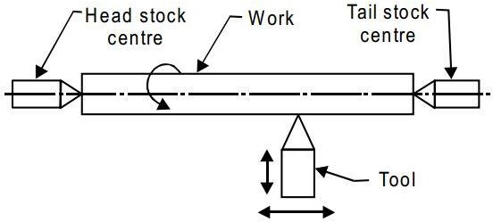

## REQUIRMENTS OF LATHE MACHINE TO REMOVE METAL

1. Tool must have sharp cutting edge .
2. Both tool and work piece should be held rigidly.
3. Tool much be made of harder material than work piece.
4. There must be relative motion between job and tool.

## PRINCIPLE PARTS OF A LATHE AND THERE FUNCTIONS

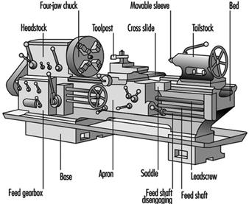

* 1. **THE MAIN PARTS OF LATHE MACHINE**
     1. **BED-** The bed is the base of foundation of the lathe. It is a heavy and rigid casting made in one piece to resist deflection and vibration. It holds or supports all other parts i.e. head stock, tailstock, carriage etc.
     2. **HEAD STOCK-** The headstock assembly is permanently fastened to left hand end of the lathe. It serves to support the spindle and driving arrangements.
     3. **TAILSTOCK** – It is an important part of lathe machine made of cast iron or mild steel. It is located in the innerways of lathe bed at the right hand end of the bed.

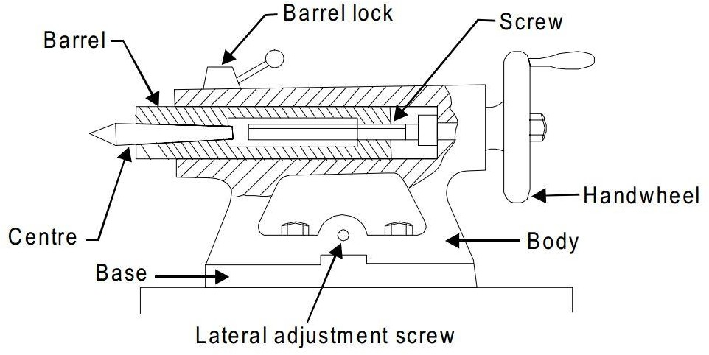

* + 1. **TOOL POST –** It mounted above the compound rest. A T-slot is machined in the compound rest to accommodate the tool post. Its serves to rigidly clamp the cutting tool or the tool holder in a desired position.

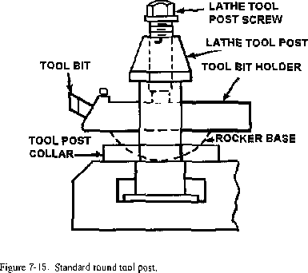

## LATHE OPERATIONS

* + 1. **PLAN TURNING-** It is an operation of removing access amount of material from the surface of the cylindrical work piece.

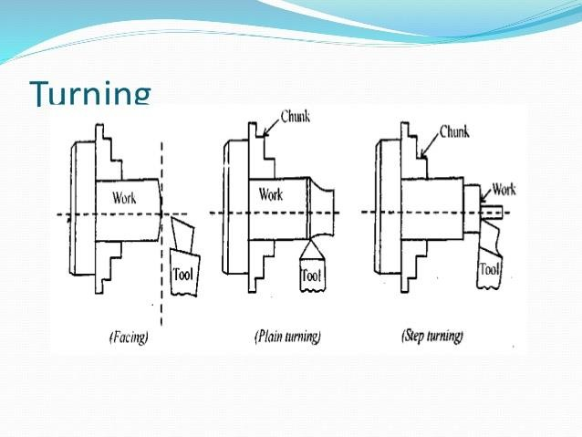

* + 1. **STEP TURNING –** It is also known as shoulder turning. It is the plan turning operation at different length with varied diameter on same work piece.

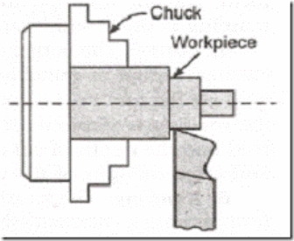

* + 1. **FACING –** The lathe operation of finishing the ends of the work to make the end flat and smooth and to make the piece of required

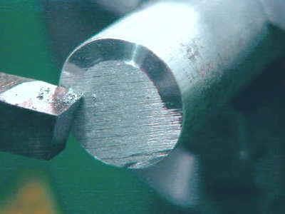

# CHAPTER– 4 (BORING)

**4.1- INTRODUCTION-** The process of enlarging the existing hole with single point cutting tool either by revolving the tool or job is called boring.

* 1. **PRINCIPLE OF BORING-** In horizontal boring machine, the work piece is held on the machine table and kept stationary, while boring tool revolves.

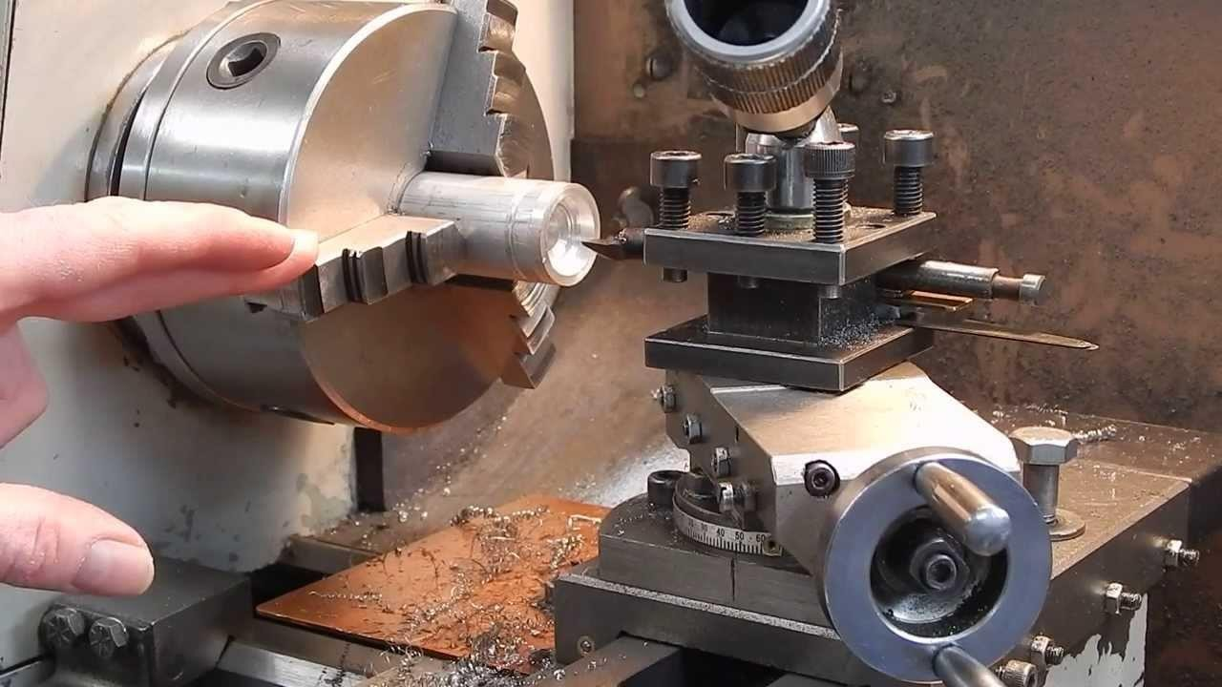

* 1. **BORING TOOL-** A boring tool consists of a single point cutting tool held in a tool holder known as Boring Bar.

THESE ARE TWO TYPES

* + 1. Rotating type.
    2. Non-rotating type.

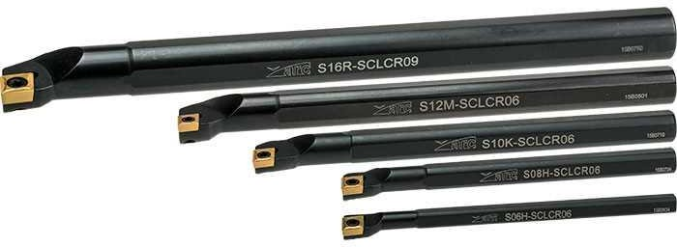

## BORING BARS

A boring bar carrying a cutter or cutters tools enable holes to be bored is known as a boring bar.

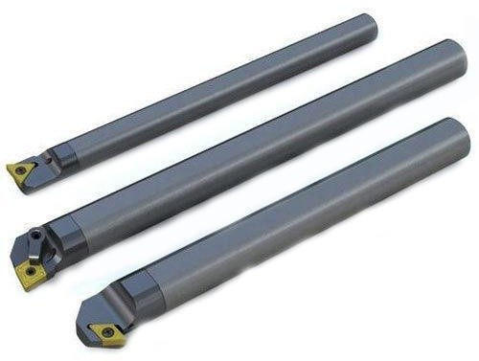

## BORING HEAD

A head like a part used for clamping boring tool inside it to perform a boring operation on a boring machine is known as Boring Head.

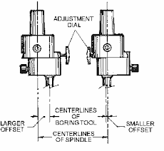

# CHAPTER– 5 (SHAPING AND PLANNING)

* 1. **INTRODUCTION -** The shaper or shaping machine is a reciprocating type of machine tool use of producing small flat surface with the help of a single point cutting tool reciprocates over the stationary work piece.

## EXAMPLE OF SHAPER WORK

1. Shaping of vertical groove.
2. Shaping horizontal flat surfaces.

(C) Shaping in V-block.

## WORKIN PRINCIPLE OF SHAPER

The job is held on a suitable device clamped rigidly on the machine table. The cutting tool is held in the tool post mounted on the ram of the shaper.

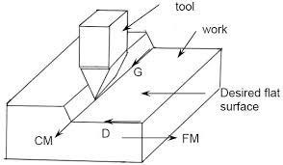

## PRINCIPLE PARTS OF A SHAPING MACHINE

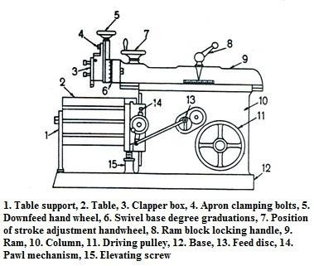

* 1. **SHAPER TOOL**

The cutting tool used in a shaper is a single point cutting tool having rake clearance and other tool angles to a similar lathe tool.

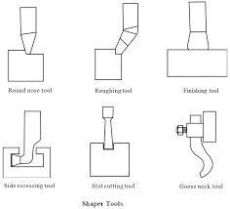

## – HOLDING JOB ON A V-block

V-blocks are used to hold cylindrical work piece over the table.

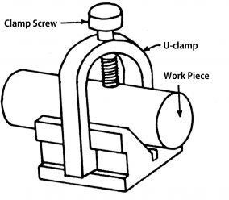

# CHAPTER -6 (BROACHING)

**1. INTRO:-** Broaching is a process of removing metal by pushing a cutting tool called BROACH which have successively higher cutting edge in a fixed part. Each tooth removes a predetermined amount of material.

* 1. **TYPES OF BROACHING:-**Broaches used in industry can be classified into following ways-
     + 1. According to method of operation-push, pull or stationary broaches.
       2. According to types of operation-internal and external broaches.
       3. According to shape-solid, inserted, tooth, built up or replace cabal.
       4. According to function- roughing, finishing, keyway, burnishing , sizing and serrating.
  2. **ELEMENTS AND NOMECLAURE OF A BROACHES:-** A broaching tool or broach is an elongated tool provided with a series of multiple teeth positioned in tandem in an arrangement, where by each successive tooth is slightly higher than its predecessor.
     + 1. **PULL END:-**The end of the pool broach which contain shank is called pull end.
       2. **FRONT PILOT:-**The portion of broach which enters the hole before the teeth start cutting action is called front pilot.
       3. **REAR PILOT:-**Its size and shape conform to those finished hole and provides support to the broach after the cutting process is over
       4. **ROUGHING AND SEMIFINISHING TEETH:-**These teeth are used for removal of stock.
       5. **FINISHING TEETH:-**These teeth are used for finishing the components.
       6. **LAND:-**The upper portion of the teeth is called land.
       7. **PITCH:-**The linear distance major between the cutting edge of the tooth and the corresponding point on the next tooth is called pitch.
       8. **CLEARENCE ANGLE:-** This correspondence to the relief angle of single point cutting tool.
       9. **RAKE ANGLE:-** It is also known as hook angle. It corresponds to the rake angle lathe tool.
       10. **DEPTH:-** Depth is the vertical distance through which teeth are cut on broach blank.
  3. **TYPES OF BROACHING MACHINE:-**
     + 1. **Direction of broach movement.**
* Horizontal broaching machine
* Vertical broaching machine

## Method of cutting

* Pull broaching machine
* Push broaching machine
* Continuous broaching machine

## The surface to be machined

* Internal broaching machine
* External broaching machine

## Method of drive

* Hydraullic drive
* Electro mechanical drive
* Mechanical drive

# CHAPTER -7 (JIGS AND FIXTURES)

* 1. **JIG:-** A jig may be defined as a device which holds and locates the work piece and guides and control the cutting tool relative to the work piece.
  2. **FIXTURE:-** A fixture is a work holding device which holds and positioned the work, but does not it in itself guide locate and position the cutting tool.\
  3. **ELEMENTS OF JIG/FIXTURE:-** The following are the elements of jig/fixture
* Locating elements
* Clampimng elements
* A rigid body into which the workpiece are loaded
* Tool guiding elements
* Elements for positioning
  1. **USES OF JIG/FIXTURE:-**
* Laborious marking operation of components is eliminated
* Greater machining accuracy is obtained
* Productivity increases
* Semi skilled labour may be employed
* The machine tool is full or partially automated
  1. **PRINCIPAL OF JIG/FIXTURE DESIGN:-** The design of jig and fixture is based on a number of fundamental principles which must be understood properly before commencing actual design.
  2. **CLAMPING DEVICES:-** Any devices used for clamping a work in a jig/fixture is known as clamping device of jig/fixture.
  3. **DRILLING JIG:-** A drilling jig is used for drilling holes in a large number of components on an interchangeable basis. In practice, a large variety of drilling jig are used.

# CHAPTER-8 (CUTTING FLUIDS)

* 1. **CUTTING FLUID:-** Any substance applied to a tool during a cutting operation to facilitate the removal of cheaps and increases to life is known as cutting fluid.
  2. **FUNCTION OF CUTTING FLUID:-** The main function of the cutting fluid are as followed
* To reduce cutting forces
* To decreases wear and tear of the tool
* To provide lubrication effect to the tool
* To improve surface finish and machinability
  1. **PROPERTIES OF CUTTING FLUID:-** There are following cutting tool
* It should be chemically stable
* It should have a high flash point
* It should case no skin irritation
* It should be low price and economical in cost
* It should prevent the electro chemical effect of corrosion
  1. **TYPES OF CUTTING FLUID :-** There are main types of cutting fluid are given below –
* Neat cutting oils
* Soluble oils
* Synthetic fluids
* Semi synthetic fluids
* Mineral cutting oil
* Chemical additive oils
* Sulphurised mineral oil
* Chemical compounds
  1. **CHARECTIRISTICS OF A GOOD LUBIRICANT :-**
* **VISCOSITY:-** Viscosity is the property of lubricant by virtue of which it offers resistance to the movement of one layer of lubricant over an adjacent layer.
* **VISCOSITY INDEX:-** The viscosity of a lubricating oil changes considerable with temperature.
* **FLASH AND FIRE POINT:-** Flash point of a lubricating oil is the lowest temperature at which it gives sufficient vapours as to form an inflammable mixture with air and vapours gives rise to a momentary flash upon the application of test flame. Fire point is the lowest temperature at which the lubricating oil must be heated to burn continuously when a test flame is applied to it.
* **POUR POINT :-**It is the temperature below which the lubricating oil can not be used as a lubricant.
* **OILINESS:-** The oiliness of a lubricant may be defined as the capacity of an oil to maintain a continuous film under high pressure and speed.